# **Chapter 4: Project Planning**

## **4.1 Work Breakdown Structure (WBS)**

WBS is a process that helps in breaking down of complex step into multiple steps. WBS splits and achieve large projects so we can get things done faster and more efficiently. WBS is a hierarchical tree structure that outlines our project and breaks it down into smaller, more manageable portions. The main goal of a WBS is to make a large project more manageable. Breaking it down into smaller portions means work can be done instantaneously by different team members, leading to better team productivity and easier project management overall.

The broke down of the project Mark Sheet Generator is:

**Project Management:**   
Project Management is the application of knowledge, skills, tools and techniques to project activities to meet the project requirements. Here we make feasible study, planning, monitoring and controlling aspects of the project.

**Analysis:**In the analysis model, information, functions and the behavior of the system is defined and these are translated into the architecture, interface and component level design in the 'design modeling'.

**Design:**In design we will be preparing structural model, behavior model and UI designs.   
 **Implementation:**Here, we will be making database and coding will be done.

**Testing:**Black box and white box testing will be performed in this part.

**Documentation:**In this portion, user guide and final report will be prepare.

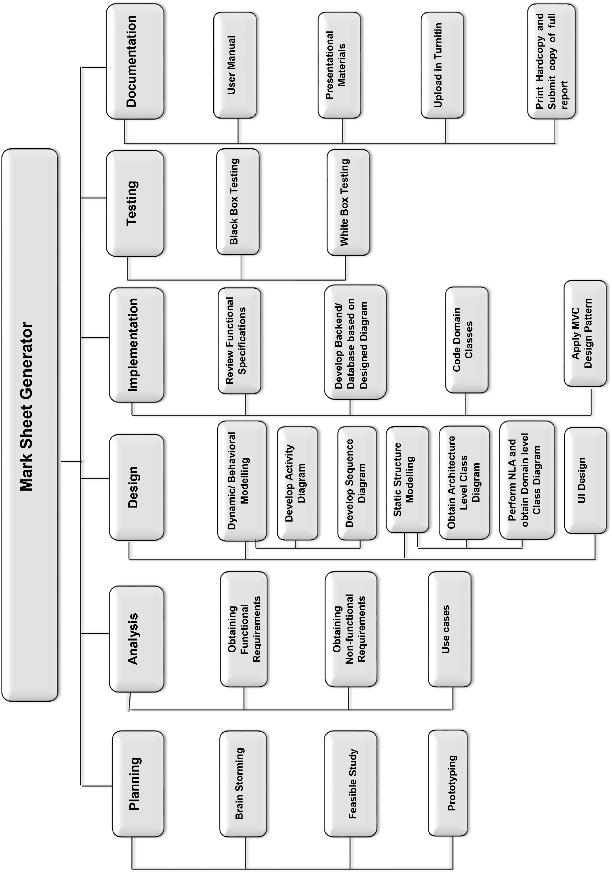

## **4.2 Milestone**

A task of zero time that expresses an important attainment in a project. The milestones denote a clear series of events, which gradually build up until the project, is complete. The milestones in the project is one of the ways of knowing the project progressing. They have zero period as they represent an achievement, or a point of time in a project. Task collaboration is a key feature of a milestone as milestone has start and end date depends on a task’s start and end date.

***(what-are-project-milestones, 2018)***

The milestone for this project, **Mark Sheet Marker** is shown in the following:

|  |  |  |  |  |
| --- | --- | --- | --- | --- |
| **S.No.** | **Topic** | **Start Date** | **End Date** | **No. Of days** |
| **1.** | **Proposal** | 26th March 2019 | 9th April 2019 |  |
| **2.** | **Analysis** | 10th April 2019 | 8th May 2019 |  |
| **2.1** | Obtaining Functional Requirements |  |  |  |
| **2.2** | Obtaining Non-functional Requirements |  |  |  |
| **2.3** | Use Cases |  |  |  |
| **3** | **Design** | 9th May 2019 | 3rd June 2019 |  |
| **3.1** | Dynamic/ Behavioral Modelling |  |  |  |
| **3.2** | Activity Diagram |  |  |  |
| **3.3** | Sequence Diagram |  |  |  |
| **3.4** | Static Structure Modeling |  |  |  |
| **3.5** | Architecture Level Class Diagram |  |  |  |
| **3.6** | Domain level Class Diagram by NLA |  |  |  |
| **3.7** | UI Design |  |  |  |
| **4** | **Implementation** | 4th June 2019 | 24th June 2019 |  |
| **4.1** | Review functional Specifications |  |  |  |
| **4.2** | Backend/ Database design based on diagram design |  |  |  |
| **4.3** | Code Domain Classes |  |  |  |
| **4.4** | MVC Pattern implementation |  |  |  |
| **5** | **Testing** | 25th June 2019 | 1st July 2019 |  |
| **5.1** | Black Box Testing |  |  |  |
| **5.2** | White Box Testing (Unit Testing) |  |  |  |
| **6** | **Documentation** | 2nd July 2019 | 12th July 2019 |  |
| **6.1** | User Manual |  |  |  |
| **6.2** | Presentation Materials |  |  |  |
| **6.3** | Final documentation |  |  |  |

## **4.3 Gantt Chart**

A project management tool that helps in assisting of the plans and scheduling of projects is a Gantt chart. In Gantt chart, project management timelines and tasks are used for conversion of a horizontal bar chart, illustrating start and end dates also dependencies, scheduling and deadlines. This is beneficial to keep tasks on track.

The Gantt chart of **Mark Sheet Generator** is :